**CATHOLIC REGIONAL COLLEGE SYDENHAM 2020**

**Software Development – UNIT 3**

**Working Modules – Outcome 301**

**SAC 2021 - Part 3 of 3**

**Name:____________________________________ Date Due:**

Marking Rubric

|  |  |  |  |
| --- | --- | --- | --- |
| **Item #** | **Item Description** | **Marks Available**  (46 marks) | **Marks Awarded** |
| **1** | Create a Windows Forms App that loads the exam file into a list of string arrays. | 5 |  |
| **2** | Implement First and Next navigation buttons and a ShowFields routine | 4 |  |
| **3** | Pass or Fail calculated field | 4 |  |
| **4** | Validation button | 3 |  |
| **5** | Search name function | 9 |  |
| **6** | Test cases | 10 |  |
| **7** | Drawing Program | 10 |  |
| **8** | Internal Documentation | 5 |  |

**Exam File**

**Student,Subject,Score**

John,Maths,70

Tracy,Maths,65

Henry,Maths,45

William,Maths,70

Barbara,Maths,65

Sally,Maths,49

Peter,Maths,50

**Note** Item 8 requires that you use descriptive and consistent variable naming conventions, procedure headings and appropriate inline comments. 5 marks will be awarded for good internal documentation practices

**Q6 Test cases**

### **(a)** Write a comprehensive test case for the Score field validation. (5 marks)

Copy your test case here

If Score is equal or greater than 0 and equal or less than 100 a message should appear displaying Valid. If it isn’t it will display a message saying invalid score

|  |  |  |  |  |  |
| --- | --- | --- | --- | --- | --- |
| Test Case | Test Step | Test Data | Expected Result | Actual Results | Pass/Fail |
| Check if Score is valid | 1- Launch application  2- User finds exam results using navigation button  3- Application uses the score result  4- User presses validate | 0  100  -1  101 | Valid  Valid  Invalid Result  Invalid Result | Valid  Valid  Invalid Result  Invalid Result | Pass  Pass  Pass  Pass |

### 

### **(b)** Write a comprehensive test case for the search routine.

Copy your test case here: (5 marks)

Program enters users' search into funcSearch and it makes it upper case then if it’s found in the name column it will go to the first target in the list, if not it will display a message box stating This isn’t found. Also if the user doesn’t type anything it will display a message box stating not found. Furthermore, if the user types part of a name it will still go to that first instance.

|  |  |  |  |  |  |
| --- | --- | --- | --- | --- | --- |
| Test Case | Test Step | Test Data | Expected Result | Actual Results | Pass/Fail |
| Search Function | 1- Launch application  2- User types name into search bar  3- User presses Search | Nothing is written  John  JOHN  Noel  1  TrAcY  ;  JO  HenR | Please enter a name  Displays Row with John  Displays Row with John  This isn’t found (message box)  This isn’t found (message box)  Displays row with Tracy  This isn’t found (message box)  Displays Row with John  Displays Row with Henry | Please enter a name  Displays Row with John  Displays Row with John  This isn’t found (message box)  This isn’t found (message box)  Displays row with Tracy  This isn’t found (message box)  Displays Row with John  Displays Row with Henry | Pass  Pass  Pass  Pass  Pass  Pass  Pass  Pass |

**Q7 Drawing Program**

Create a Windows application that allows the user to draw on the client area of a windows form. The program will draw when the user holds down the left mouse button and moves the cursor. Drawing will stop when the left mouse button is released. (10 marks)

The application interface is shown here:

1. Radio buttons allow for line or rectangle drawing. (2)
2. Line drawing is the default mode when the program starts. (1)
3. If the user clicks Rectangle it will draw rectangles instead of lines. (6)
4. A border is to be displayed around the drawing surface. (1)

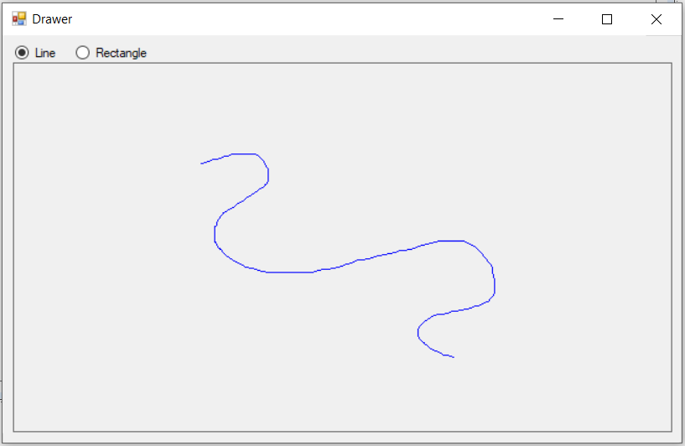

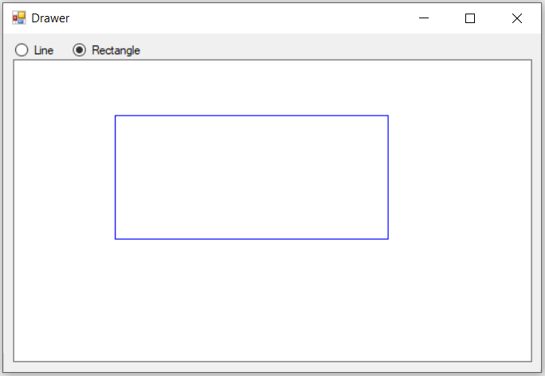

**Code Hints:**

The line drawing code has been given previously. It draws a line from X1, Y1 to the current position of the cursor (given by e.X and e.Y). g is the ‘graphics context’ ie the drawing surface of the picture box control. The code is called in the MouseMove event handler.



This code will draw a rectangle starting at (X1, Y1) of width e.X - X1 and height e.Y - Y1



Your program will decide which shape to draw (line or rectangle) according to which radio is currently checked. You should test the state of the line radio button in the MouseMove event handler. If it is checked then your program should draw a line. If it is not checked then the program will draw a rectangle.

